Data Flow Diagrams and User Stories
Date: 18th June 2026
Team ID:
Project Name: ShopEZ E-Commerce Platform
Maximum Marks: 4

DFD Level 0 Context Diagram
The Level 0 DFD (Context Diagram) shows the highest-level view of the ShopEZ system. The central process is the ShopEZ Platform. It interacts with three external entities:
- Buyer: Sends registration/login, search queries, and cart/order requests. Receives product listings, cart updates, and order confirmations.
- Seller: Sends product creation/update/deletion requests. Receives inventory status and order details for their products.
- Admin: Sends user/order management commands. Receives platform statistics and management reports.
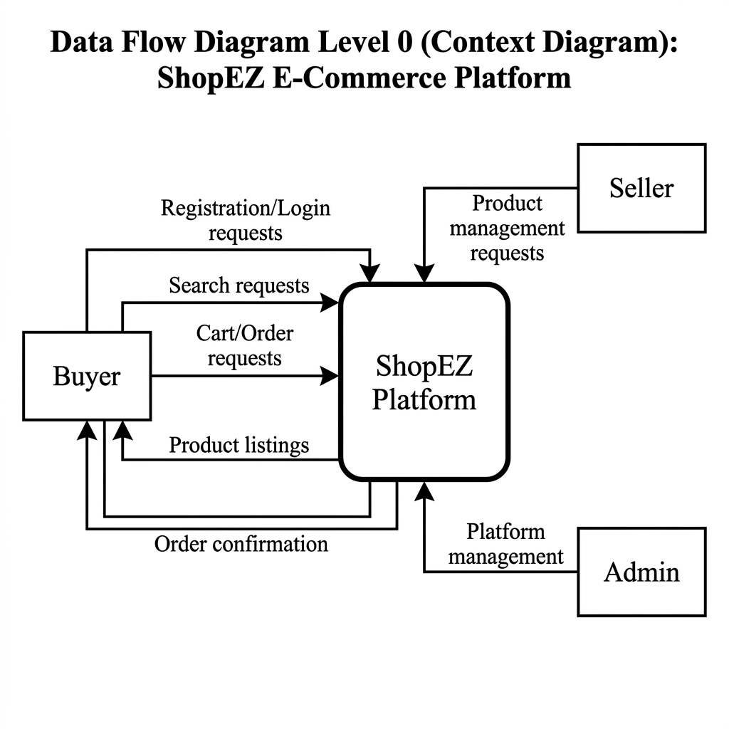

DFD Level 1 Simplified Data Flow
The Level 1 DFD breaks the central system into sub-processes. Data flows between the following processes and data stores:
- Process 1.0 User Authentication â†’ Data Store: Users Collection (MongoDB)
- Process 2.0 Product Management â†’ Data Store: Products Collection (MongoDB)
- Process 3.0 Cart Management â†’ Data Store: Cart Collection (MongoDB)
- Process 4.0 Order Processing â†’ Data Store: Orders Collection (MongoDB)
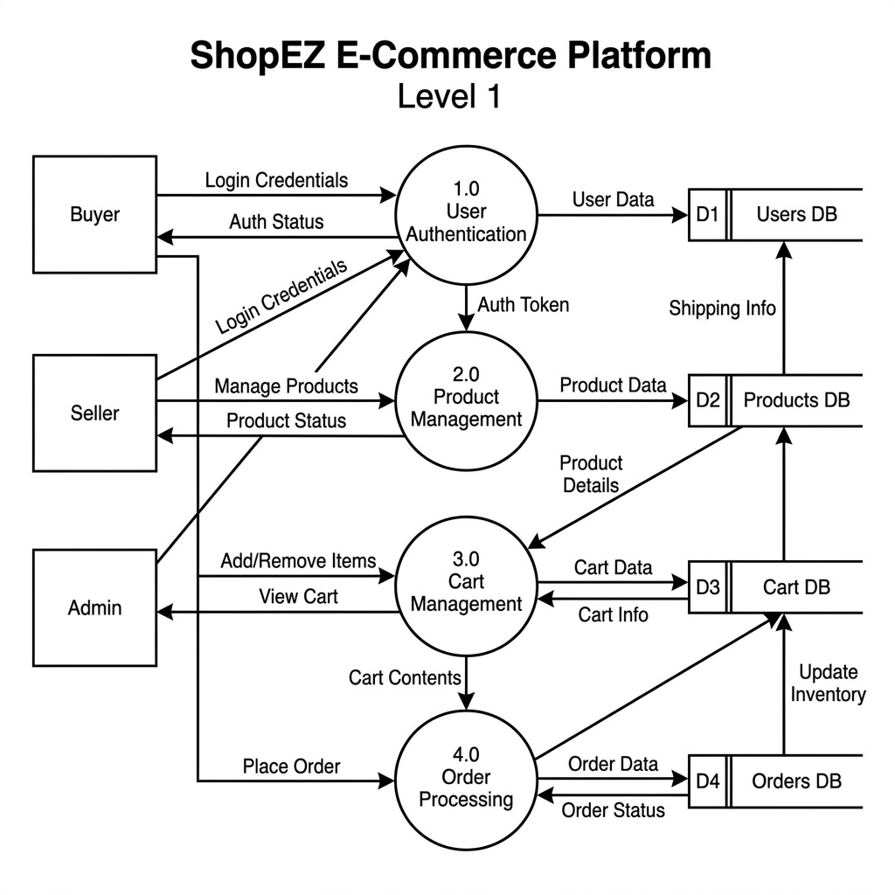

User Stories
User Type | Functional Requirement (Epic) | User Story No. | User Story / Task | Acceptance Criteria | Priority | Release
Buyer (Web) | Authentication | USN-1 | As a buyer, I want to register using my email and password so I can create a shopping account. | User receives confirmation and is redirected to homepage after registration. | High | Sprint 1
Buyer (Web) | Authentication | USN-2 | As a buyer, I want to log in securely so my account data is protected. | JWT cookie is set on successful login. Invalid credentials show error message. | High | Sprint 1
Buyer (Web) | Product Catalog | USN-3 | As a buyer, I want to browse a paginated product catalog so I can explore all available items. | Products are displayed with image, name, category, and price. Pagination works correctly. | High | Sprint 1
Buyer (Web) | Product Catalog | USN-4 | As a buyer, I want to filter products by category so I can find what I need quickly. | Selecting a category returns only matching products. | High | Sprint 1
Buyer (Web) | Shopping Cart | USN-5 | As a buyer, I want to add products to my cart and adjust quantities so I can manage my purchases. | Cart updates in real-time. Navbar cart counter reflects current item count. | High | Sprint 2
Buyer (Web) | Order Management | USN-6 | As a buyer, I want to checkout and receive an order confirmation so I know my order was placed. | Order is saved in DB, cart is cleared, and order history is updated. | High | Sprint 2
Seller | Seller Dashboard | USN-7 | As a seller, I want to add, edit, and delete my products from a dashboard so I can manage my store. | Products added by seller appear on the catalog. Only seller's own products are editable. | Medium | Sprint 2
Administrator | Admin Panel | USN-8 | As an admin, I want to view all users, orders, and products so I can manage the platform operations. | Admin can view and delete any user, order, or product. Regular users cannot access admin routes. | Medium | Sprint 3

